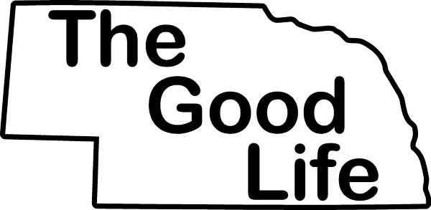

Dear Forensics Friends,

To honor the history of our state and the friendship between our academic institutions, we invite you to the third annual University of Nebraska “THE GOOD LIFE TOURNAMENT”.

This will be a swing tournament with the first half asynchronous online by UNL from February 17-21st and the second half a one-day in-person tournament hosted by UNO on their Omaha campus Saturday, February 22nd, 2025. All information and registration can be found on [www.speechwire.com.](http://www.speechwire.com/)

# Events and Point Distribution:

* We will offer competition in all eleven AFA events and appropriate elimination rounds. AFA tie breaking procedures will be followed throughout the tournament. Students will be recognized for 1st- 6th places in each individual event as well as the top three teams in team sweepstakes.
* Points for team awards will be as follows: 10 for 1st, 8 for 2nd, 6 for 3rd, 4 for 4th, 2 for 5th, 1 for 6th. Ties in team sweepstakes will be broken by number of finalists, then number of 1’s, 2’s, 3’s, etc.

# Entry Deadline:

* Entries and videos are due Tuesday, February 18th by 5:00 p.m. CST via [www.speechwire.com.](http://www.speechwire.com/) Fees will be assessed based on information we have received by February 20th at 12:00 p.m. CST.

# Fees:

* For several years, UNL and UNO have co-hosted a late season tournament in order to give teams an opportunity to stretch their budgets**.** To do this, we offer low entry fees of $4 per slot; each uncovered slot will incur an additional $12. Please provide enough usable judges to cover your entry.
* A fee of $10 will be charged for all changes made at registration. A fee of $50 will be charged for any judge dropped at registration. Such changes make it difficult to run a timely and efficient tournament. Please try to communicate all changes to the tournament directors ahead of time.

|  |  |
| --- | --- |
| **For the Async Half Make Checks Payable to:**  UNL FORENSICS | **Please send all Checks to:**  **Aaron Duncan**  **Director of Speech & Debate**  375 Pound Hall  University of Nebraska–Lincoln  Lincoln, NE 68588-0329 |
| **For the In-Person Half**  **Pay with Cash or Make Checks Payable to:**  UNO Mavforensics | **Please send all checks to:**  Amanda VonGoodrich  Co-Director of Mavforensics  Dodge Campus: ASH105M  University of Nebraska – Omaha  Omaha, NE 68182 |

**Individual Events**

* **No student may enter more than three (3) events in this single-flight tournament.**
* Finalists will advance based on lowest cumulative rank, then highest cumulative rating points, then highest reciprocal.
* First place will be awarded to the competitor with the lowest cumulative rank. Ties in finals will be broken first on predominance of 1’s, second judge’s preference, and finally rating points. Ties in team points and individual sweepstakes will be broken on numbers of finals followed by number of 1, 2, 3’s. Individual sweepstakes is open to any competitor who has three or more events.
* All rules for the 11 AFA events should follow the “AFA-NST Description of Events” found at <http://www.mnsu.edu/cmst/niet/eventdescriptions-new09-10.htm>

**Async UNL Tournament Schedule**

Friday February 14th -- LP Prompts Posted on Speechwire

Tuesday February 18th -- ALL entries due by 5pm

Friday February 21st -- ALL ballots due by 12pm

Friday February 21st -- Awards/Results will be sent out by 4pm

# In person UNO Tournament Schedule: Saturday, February 22nd, 2025 (All times CST)

We will offer all eleven AFA individual events. Schedule subject to change based on entry numbers.

|  |  |
| --- | --- |
| 8:30 am | Registration |
| 9:00 | Extemp Draw |
| 9:30 | Round 1 (all events) |
| 10:30 | Extemp Draw |
| 10:45 | Round 2 (all events) |
| 12:30 pm | Lunch |
| 12:45 | Extemp Draw |
| 1:00 | Finals (all events) |
| ASAP | Awards |

# Lunch

# Lunch will not be provided for the in-person portion of our swing, but there are several lunch options for delivery and pickup within 1 mile of campus. This information will be available upon registration.

# Judges Code of Ethics:

* We believe it is important to create a positive educational environment for all students participating at the tournament. Any judge found to be making comments on ballots that are deemed to be racist, sexist, or otherwise discriminatory by the tournament director will be removed from the judging pool immediately. It is also our expectation that all judges make supportive comments and do not use overly penal speaker points. If judges are found to be engaging in those behaviors, they will be asked to change immediately or be removed from the judging pool. Any schools that have judges removed from the pool will be charged for uncovered slot fees.

Amanda VonGoodrich Aaron Duncan

Co-Director of Forensics Director of Forensics University of Nebraska Omaha University of Nebraska Lincoln

(402) 616-5406 (402) 472-6920

[agoodrich@unomaha.edu](mailto:agoodrich@unomaha.edu) [aduncan3@unl.edu](mailto:aduncan3@unl.edu)

*Special Needs: If you have a student or coach with special needs, please let us know. We will be happy to provide accommodations.

